Autism Social Groups
On Friday Afternoons between 1pm - 3pm, People First Merseyside’s Autism Advocacy Service will be holding a weekly social group for people over 18 with a diagnosis of Autism or Asperger’s.

This will be a safe space where you can: -
- Meet new people with the same condition,
- Make new friends,
- Chill out,
- Have a tea, coffee or soft drink and get involved.
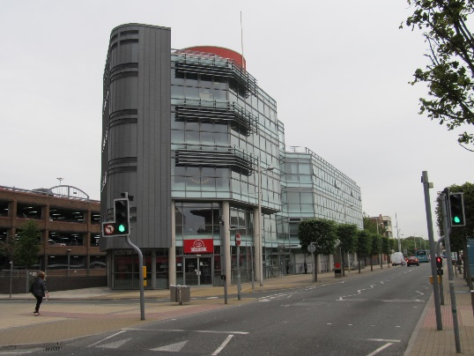
This will take place at
People First Merseyside,
The Investment Centre,
375 Stanley Road, L20 3EF.

If you would like to attend or find out more, please get in touch with:
Lisa Smeaton
Lisas@peoplefirst.uk.com
0151 329 2137 or 07534 289 960.

How to find us: -

By Bus: -
From Southport, Thornton,
Crosby you can get the X2, 47,
53 and 54 to the Lidl
supermarket opposite North
Park. Once off the bus cross over Stanley Road and walk past the Salvation Army and we are the entrance next door to the dentist on the 3rd floor.

From Liverpool you can get the 47, X2, 52, 53, 54, 55, 300 to Bootle Strand. Turn Right off the bus
and walk towards the traffic lights. Just before the lights you will see a glass fronted building on the left-hand side, this is The Investment Centre.

By Train: -
From Liverpool get the Southport bound train and get off at Bootle New Strand. As you come out of the station you will see Marsh Lane police station and the bus terminal on the opposite side. Cross over and take the side street that runs between these and turn left at the end. The entrance to The Investment Centre is via the sliding doors next to Central Perk.

From Southport get the Liverpool bound train and the instructions are the same as above for people coming from Liverpool via train.

If there any problems or if you get a
bit anxious, please call Lisa on
0151 329 2137 who will direct you.

