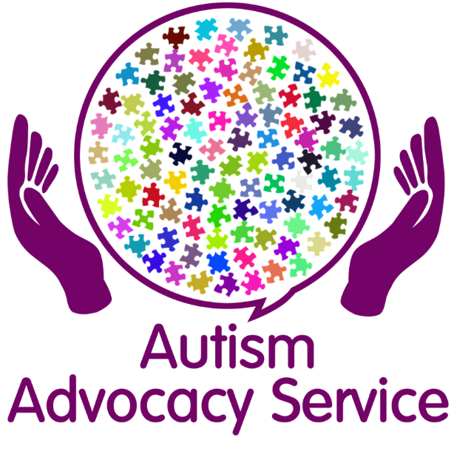

The Autism Advocacy Service will offer support, advice and guidance to anyone who lives in Sefton and has a diagnosis of Autism.
Autism Advocacy Drop in’s
10.00 am – 12.00 pm
The dates will be: -
9th November 2020
23rd November 2020
7th December 2020
14th December 2020
Virtual Drop in’s on Zoom
16th November 2020
30th November 2020
There will be more drop ins sessions in 2021
Session will take place at:
People First Merseyside
The investment Centre
Stanley Road
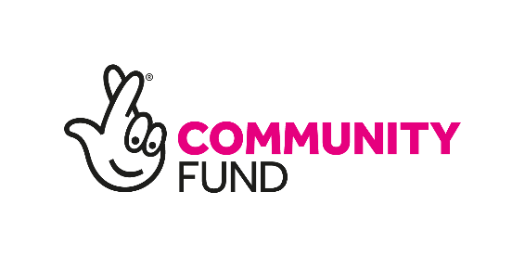
Bootle,
L20 3EF

