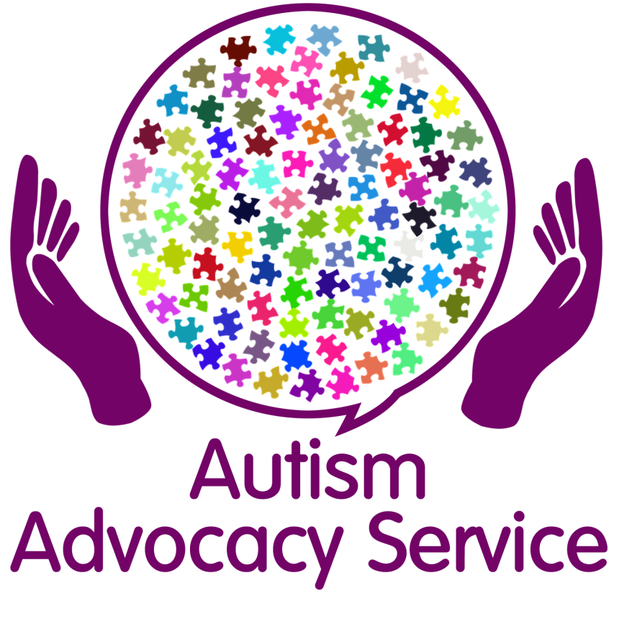

Welcome to the People First Merseyside Autism Advocacy Service
Would you like support with:
- Increasing your confidence to take control of issues affecting your life?
- Help with removing communication barriers?
- Be able to speak up about YOUR needs?
- Accessing appropriate services and making contact and introductions?
Have you a diagnosis of Autism without a learning difficulty? Have you struggled more than you expected during Covid? Do you feel like you need someone to talk to? Do you need help in finding other services that offer support?
If so get in touch. We also offer other services that we can provide details of.
Our contact details are:
Name: Lisa Smeaton Email address: lisas@peoplefirst.uk.com
Telephone: 0151 329 2137/07534289960 Website: www.peoplefirstmerseyside.co.uk
We are based at the Investment Centre in Bootle
375 Stanley Road, Bootle, L20 3EF
This service is based in Sefton for Sefton residents with a diagnosis of Autism/Asperger’s without a learning disability/difficulty.

