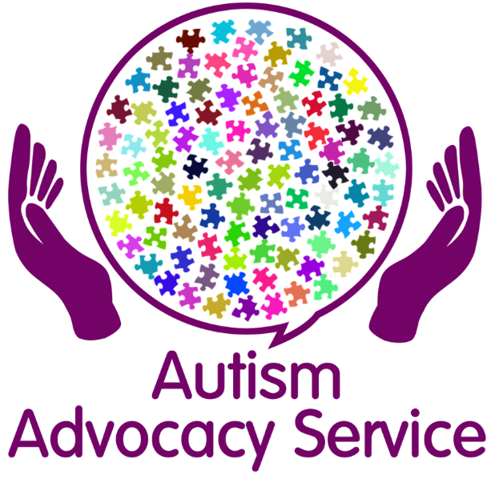

The Autism Advocacy Service will offer support, advice and guidance to anyone who lives in Sefton and has a diagnosis of Autism.
Autism Advocacy Drop in’s
Session will take place at:
People First Merseyside, The Investment Centre, Stanley Road, Bootle, L20 3EF
10.00 am – 12.00 pm
The dates will be: -
11th January 2021
25th January 2021
1st February 2021
15th February 2021

Virtual Drop in’s on Zoom
18th January 2021
8th February 2021

There will be more drop ins sessions in 2021
To get the Zoom code or for more information
contact Lisa Smeaton - 07534 289 960
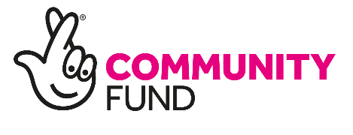
or email lisas@peoplefirst.uk.com

