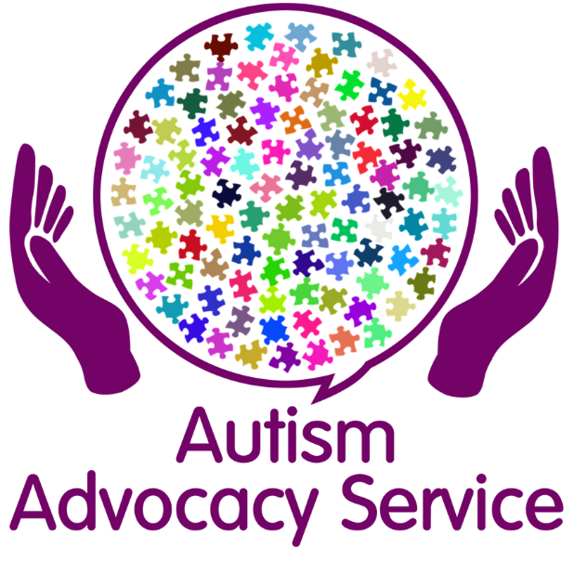

The Autism Advocacy Service will offer support, advice and guidance to anyone who lives in Sefton and has a diagnosis of Autism.
Autism Advocacy Drop in’s
10.00 am – 12.00 pm
The dates will be: -
9th November 2020
23rd November 2020
7th December 2020
14th December 2020
There will be more drop ins sessions in 2021
Session will take place at:
People First Merseyside The investment Centre Stanley Road
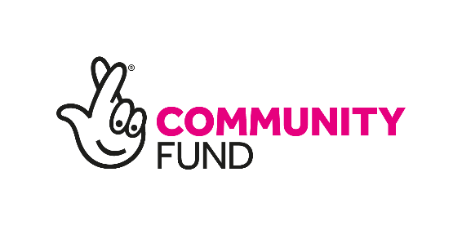
Bootle,
L20 3EF

